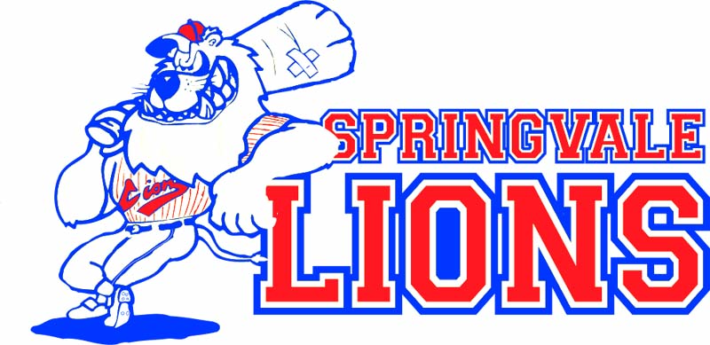

SPRINGVALE LIONS BASEBALL CLUB

code of Conduct
This Code of Conduct outlines the minimum standards for all persons involved with Springvale Lions Baseball Club. All items below will apply when playing, training or when taking part in any and all club-sanctioned activities.
- Act within the rules and spirit of baseball.
- Promote fair play over winning at any cost.
- Encourage and support opportunities for people to learn appropriate behaviors and skills.
- Support opportunities for participation in all aspects of the sport.
- Treat each person as an individual.
- Show respect and courtesy to all involved with the sport.
- Always act in a professional manner with regards to any players, coaches, officials, staff, spectators and supporters
- Respect the rights and worth of every person, regardless of their age, race, gender, ability, cultural background, sexuality or religion.
- Respect the decisions of officials, coaches and administrators.
- Wherever practical, avoid unaccompanied and unobserved one-on-one activity (when in a supervisory capacity or where a power imbalance exists) with people under the age of 18.
- Display appropriate and responsible behavior in all interactions.
- Display responsible behavior in relation to alcohol and other drugs.
- Act with integrity and objectivity, and accept responsibility for your decisions and actions.
- Ensure your decisions and actions contribute to a safe environment.
- Ensure your decisions and actions contribute to a harassment-free environment.
- Do not tolerate abusive, bullying or threatening behavior.

Athletes
- Give your best at all times.
- Participate for your own enjoyment and benefit.
- Play by the rules and show respect for other players, coaches and officials.

Coaches
- Place the safety and welfare of the athletes above all else.
- Help each person (athlete, official, etc.) to reach their potential. Respect the talent, developmental stage and goals of each person and encourage them with positive and constructive feedback.
- Obtain appropriate qualifications and keep up-to-date with the latest coaching practices and the principles of growth and development of young players.
- Ensure that any physical contact with another person is appropriate to the situation and necessary for the person's skill development.

Officials
- Place the safety and welfare of the athletes above all else.
- Ensure all players are included and can participate, regardless of their race, gender, ability, cultural background, sexuality or religion.
- Be consistent, impartial and objective when making decisions.
- Address unsporting behavior and promote respect for other players and officials.

Administrators
- Ensure quality supervision and instruction for players.
- Support coaches and officials to improve their skills and competencies.
- Act honestly, in good faith and in the best interests of the sport as a whole.
- Ensure that any information acquired or advantage gained from the position is not used improperly.
- Conduct club responsibilities with due care, competence and diligence.

Parents
- Encourage your child to participate, do their best and have fun.
- Focus on your child's effort and performance, rather than winning or losing.
- Never ridicule or yell at a child for making a mistake or losing a competition.
- Help out the coach or officials at training and games, where possible.
- Model appropriate behavior, including respect for other players and officials.

Spectators
- Respect the effort and performances of players and officials.
- Reject the use of harassment, bullying or violence in any form, whether by other spectators, coaches, officials or athletes.
- Always act in a professional and respectful manner whilst at games, trainings or club events – including, but not limited to, the way you interact with players, coaches, officials and other spectators

