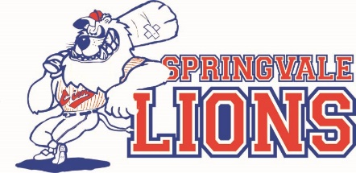

SPRINGVALE LIONS BASEBALL CLUB

Social media policy
Social Media sites such as Facebook, MySpace, Twitter, Flickr, LinkedIn, YouTube, as well as Forums and Blogs are exciting avenues expressing creativity, and sharing interests and knowledge. Participation in these online communities is therefore supported. However, over a number of years there have been repeated incidents where online discussions and posting of online content have caused distress to individuals or groups of members and has detracted from the community’s overall enjoyment of baseball.
The Springvale Lions Baseball Club (SLBC) social media policy is guided by the following key principles:
- SLBC wishes to operate in an environment where people show respect for others and their property. Respect is defined as consideration for another’s physical and emotional well being and possessions, to ensure no damage or deprivation is caused to either.
- SLBC wishes to operate in an environment that is free from harassment. Harassment is defined as any action directed at an individual or group that creates a hostile, intimidating or offensive environment. (Refer to Australian Sports Commission Guidelines for Harassment-Free Sport).
- SLBC wishes to operate in a non-discriminatory environment. Respect the right, dignity and worth of every human being - within the context of the activity; treat everyone equally regardless of gender, ethnic origin or religion.

SLBC promotes responsible use of social media and requires its members, when posting about the club and its members, an opposition club and its members, or club endorsed, promoted or conducted events or activities, to observe the following guidelines for responsible social media use.
- SLBC requires members to take responsibility for their own words and for the comments allowed on their sites or forums. SLBC members will not post unacceptable content, and will delete comments that contain it. Unacceptable content is defined as anything included or linked to that:
  - is being used to abuse, harass, stalk or threaten others
  - is slanderous, knowingly false, or misrepresents another person,
  - infringes upon a copyright or trademark
  - violates an obligation of confidentiality
  - violates the privacy of others
- SLBC members don’t post anything online that they wouldn’t say in person.
- SLBC members connect privately before they respond publicly. When members encounter conflicts and misrepresentation in social networking sites, they make every effort to talk privately and directly to the person(s) involved–or find an intermediary who can do so–before publishing any posts or comments about the issue.
- SLBC strongly discourages personal attacks. When someone who is publishing comments that are offensive, members will tell them so (privately, if possible–see 3 above).
- Anonymous comments are discouraged. All content posters should be required to supply a valid email address before they can post, authorised posters may identify themselves with an alias, rather than their real name.
- SLBC prefers members not to respond to nasty comments about them, their group, event or site. If posts veer into abuse or defamation, SLBC supports the use of disciplinary and grievance procedures to resolve issues.

Springvale Lions Baseball Club encourages all members to “think before posting”. Members should recognise that even if posting to a private section of a social networking site comments can appear in public areas through a variety of means and can easily be found. Members should avoid posting something they will regret now or later.

